

Safety Bay Senior High School

Chemistry Unit 1 & 2

**Investigation: Rates of Reaction  
Validation Test**

**NAME: ______________________________________**

Reading time: 5 minutes

Working time: 55 minutes

|  |  |  |
| --- | --- | --- |
| **Section** | **Mark** | **Percent** |
| Lab report | / 22 | ____% |
| Validation test | / 28 | ____% |
|  | | **Average:**  ____% |

1. **(7 marks)**

Glowsticks are used for parties, decoration and fun. A glowstick is a plastic tube with a glass vial inside of it. In order to activate a glowstick, you bend the plastic stick, which breaks the glass vial. This allows the chemicals that were inside the glass to mix with the chemicals in the plastic tube. Once these substances contact each other, a reaction starts taking place. The reaction releases light, causing the stick to glow for a period of time. Eventually, however, the reactants are consumed and the glowstick will stop glowing.

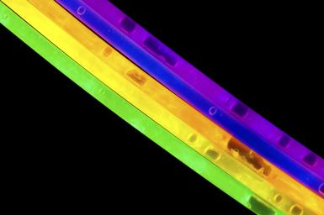 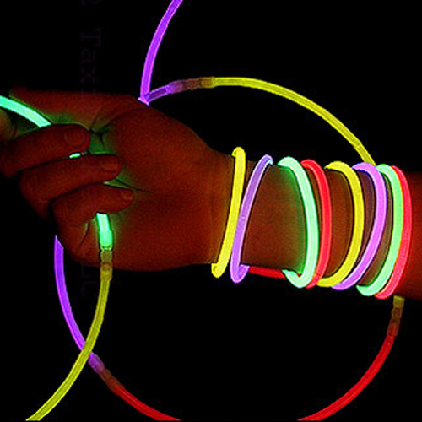

Devise an experiment which would investigate the effect of **temperature** on the chemical reaction in a glowstick.

You should clearly specify:

* Your hypothesis for this investigation (1 mark)
* The independent, dependent and controlled variables in your experiment (2 marks)
* The procedure you would follow (2 marks)
* How you would collect the results and use them to answer the aim of the investigation (2 marks)

|  |  |
| --- | --- |
| **Section** | **Marks available** |
| Hypothesis should be correctly stated and relevant.  e.g.   * *“Glowsticks at a higher temperature will glow brighter”* * *“The chemical reaction in glowsticks will proceed faster at higher temperatures”* * *“Glowsticks will stop glowing more quickly if in high temperatures”* | 1 |
| **Independent variable**   * Temperature of glowstick   **Dependent variable**   * Brightness of glowstick or amount of time for glowing to fade   **Controlled variables** (at least two):   * Colour of glow stick * Brand of glow stick * Concentration of reactants * *May think of others* | 0.5  0.5  2 x 0.5 |
| Procedure should be logical and fit needs of experiment.  e.g. *Take three glowsticks and break the internal plastic at the same time. Place one glowstick in a beaker of hot water, one in room temperature water and one in ice water. Record how long it takes before the glowing colour of the glowstick can no longer be seen.* | 2 |
| May use one of two methods:   * Comparing the brightness of the glow sticks * A brighter glowstick indicates the reaction is proceeding faster, therefore faster rate   **OR**   * Compare how long it takes for glowsticks to stop glowing * Glowing for a shorter period of time indicates the reaction was faster, therefore faster rate | 1  1  1  1 |

1. **(2 marks)**

Magnesium carbonate reacts with aqueous hydrochloric acid according to the reaction

MgCO3(s) + 2HCℓ(aq) 🡪 MgCℓ2(aq) + H2O(ℓ) + CO2(g)

An experiment was conducted to study the rate of this reaction. This was performed using the apparatus shown below.

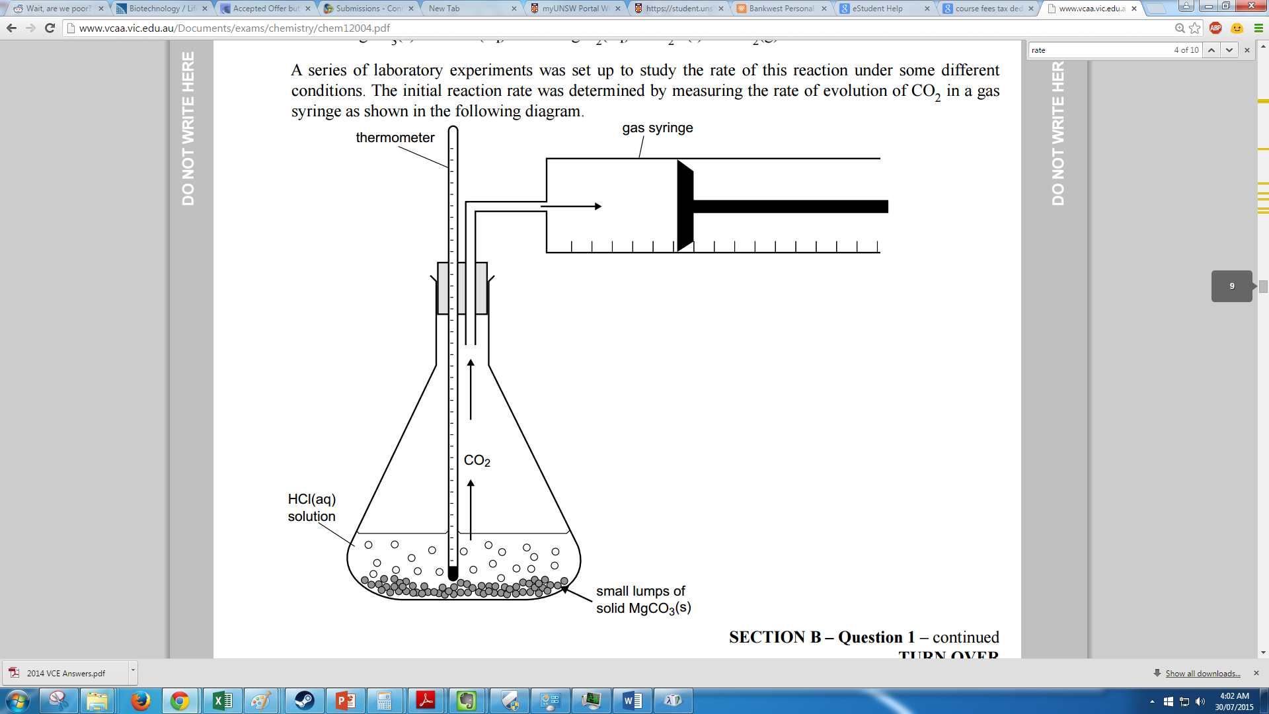

Explain how this apparatus could be used to measure the **rate** of the chemical reaction. (2 marks)

|  |  |
| --- | --- |
| **Answer** | **Marks available** |
| Answer should make references to **volume of CO2 (1 mark)** collected over a period of **time (1 mark)**  *e.g. measure how much volume of CO2 is collected per minute* | 2 |

1. **(11 marks)**

In a separate experiment, 40.0 mL of 1.00 mol L‑1 hydrochloric acid was added to 20.0 g of magnesium carbonate chips (a large excess). The flask and contents were immediately weighed and a stop watch started. The mass of the flask and contents were noted as the reaction proceeded. The following table indicates the loss in mass at various times.

|  |  |  |  |  |  |  |  |  |  |  |
| --- | --- | --- | --- | --- | --- | --- | --- | --- | --- | --- |
| Time (min) | 0 | 0.5 | 1.0 | 1.5 | 2.0 | 3.0 | 5.0 | 7.0 | 8.0 | 10.0 |
| Loss in mass (g) | 0 | 0.19 | 0.35 | 0.47 | 0.56 | 0.69 | 0.82 | 0.86 | 0.88 | 0.88 |

1. Plot a graph of ‘loss of mass’ against time on the grid below. (5 marks)

|  |  |
| --- | --- |
| **Component of graph** | **Marks available** |
| * X-axis label | 1 |
| * Y-axis label | 1 |
| * Consistent scale | 1 |
| * Title | 1 |
| * Data and trend line | 1 |

1. How long did it take for **all** of the acid to get used up? (1 mark)

|  |  |
| --- | --- |
| **Answer** | **Marks** |
| ~7-8 minutes | 1 |

1. How long did it take for **half** of the acid to get used up? (1 mark)

|  |  |
| --- | --- |
| **Answer** | **Marks** |
| Should match where loss of mass = 0.44 g  ~1-1.5 minutes | 1 |

1. The mass which is lost is due to the loss of carbon dioxide.

i. Calculate the average rate of CO2(g) production in the **first** **five minutes**. Show all working and include appropriate units with your answer. (2 marks)

|  |  |
| --- | --- |
| **Answer** | **Marks** |
| rate = rise/run = 0.82/5 = 0.164 | 1 |
| Units: g/min | 1 |

ii. Calculate the average rate of CO2(g) production in the **last five minutes**. (2 marks)

|  |  |
| --- | --- |
| **Answer** | **Marks** |
| rate = rise/run = (0.88-0.82) / (10-5) = 0.06 / 5 = 0.012 | 2 |
| *(do not penalise for wrong/no units here)* | - |

1. **(2 marks)**

Scientific reports need to be written in a certain style. The method of a scientific report must be written using past-tense and third-person perspective.

Re-write the following method so that it fits the conventions for a scientific report.

***Method:***

The first thing that I would do is to fill two beakers with 50 mL of hydrochloric acid. We would then place a piece of chalk into each beaker of acid at the same time and start the stop watch. Then you need to stir one beaker while the other ones sits on the bench and record the time it takes for the chalk to finish reacting.

|  |  |
| --- | --- |
| **Answer** | **Marks** |
| Answers may vary, but should be marked on **past tense (1 mark)** and **third-person (1 mark)**  *Example:*  *“Pieces of chalk were placed in two beakers, each containing 50 mL of hydrochloric acid. One beaker was stirred while the other beaker was not. The time taken for the chalk to stop reacting was recorded.”* | 2 |

1. **(6 marks)**

The students’ conclusion is not valid because the experimental design is flawed.

Critically review the student’s experimental design. In your response you should:

* Identify and explain **three** improvements or modifications that you would make to the experimental design (3 marks)
* Discuss the experimental outcomes you would **expect** regarding the effect of different catalysts on the heat of reaction. Justify your expectations in terms of chemical ideas you have studied this year and include a relevant diagram. (3 marks)

|  |  |
| --- | --- |
| **Answer** | **Marks** |
| Possible improvements:   * Use same volume of H2O2 in both trails * Use same concentration of H2O2 in both trials * Use same number of moles of each catalyst * Use a calorimeter with better insulation to prevent heat loss * Repeat the trial a number of times * Use a mechanical stirrer to ensure consistent mixing of reactants * Use catalysts which are in the same state (solid vs liquid)   Given students needed to *“explain”* three improvements they should also provide a reason/reasons for making these changes. Award 2/3 if changes are suggested but with no supportive reasoning. | 3x1 |
| **Comparison to expected outcomes:**  Catalyst should not affect delta H. The catalyst speed up the reaction but does not change enthalpies of products or reactants, and therefore doesn’t change delta H.  Therefore the *total* change in temperature should be the same in both cases *(assuming all variables are properly controlled…)*  An energy profile diagram should be drawn to illustrate that delta H remains constant when a catalyst is added. | 1  1  1 |